The mission of Highlands is
to provide gracious hospitality & quality Christian programs
in a majestic mountain setting
& to nurture spiritual renewal & transformation
in a safe & inclusive environment.

Thank you for bringing your group to Highlands. We hope that your retreat will meet your highest expectations. In order for our guests to have the best possible retreat experience, we are providing you with some information regarding our housekeeping cabins (with kitchens) before your arrival.

Paintbrush Named after the Indian Paintbrush, a beautiful red flower that grows abundantly in and around the
area, this rustic log cabin is a great place for groups who want to cook their own meals.

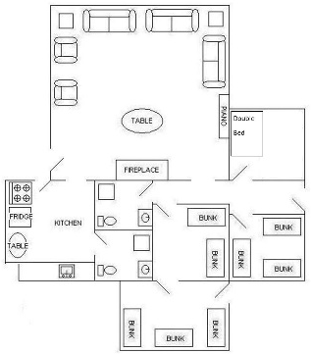
The kitchen is suited to food preparation for no more than 16 guests and is equipped with:
- A 4 burner electric range and oven
- A refrigerator/freezer (Approximately 14 cu. ft./2 shelves, 2 drawers in fridge)
- A microwave
- A coffee pot
- Propane grill and grill tools

**Cookware/Dishware for up to 16 people.

Horse Lodge If you’re a fan of the old west, you’ll love our nostalgic Horse Lodge. This Bunkhouse-style log
structure was built around 1910 and has become a favorite for many of our groups.

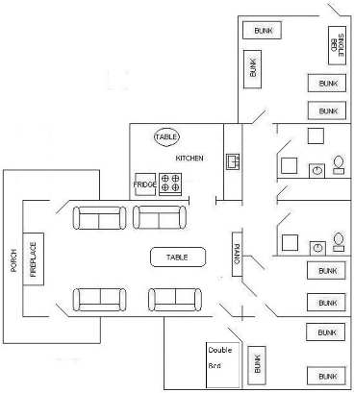
The kitchen is suited for food preparation for no more than 20 guests and is equipped with:
- A 4 burner gas range and oven
- A refrigerator/freezer (Approximately 14 cu. ft./3 shelves in fridge)
- A microwave
- A coffee pot
- Propane grill and grill tools

**Cookware/Dishware for up to 20 people.

**Cookware sets will include items such as: assorted pots, kettles, and skillets; a 9x13 baking dish; cookie sheets; mixing bowls; colander; skillet spatulas; rubber spatulas; potato masher; potato peeler; box cheese grater; measuring cups; ladles; large spoons; serving spoons; and knives. Hot pads/mitts and dish towels are also included.

**Dishware sets will include: knives; forks; spoons; plates; bowls; drinking glasses; and mugs.

Drying racks, dishwashing soap, scrubbing pads, and sanitizer tablets will be provided for washing and sanitizing items.

You are welcome to bring your own items, and coolers with ice are always a good choice to transport and store some of your items.

PLEASE notify the front desk of any damage to, spills on, or problems with appliances or
cookware/dishware discovered upon arrival or during your stay. We hope you enjoy your stay!

